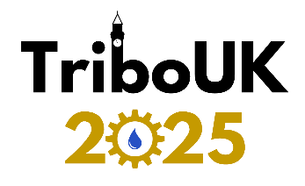

**Travel Grant Application**

Complete the below fields and submit the document to [tribouk2025@contacts.bham.ac.uk](mailto:tribouk2025@contacts.bham.ac.uk) to apply for a travel grant for TriboUK 2025. If the grant is essential to your attendance, please ensure your application has been approved before booking your travel.

Grants are available for travel, and/or one night of accommodation only. The maximum value of an individual grant is £250.

|  |  |
| --- | --- |
| Applicant Details | |
| Title: |  |
| Names: |  |
| Current Institution: |  |
| Current Position: |  |
| Contact Email: |  |
|  |  |

|  |
| --- |
| Please briefly state how a travel grant would help you attend and benefit from this conference (max 100 words). |
|  |

|  |  |
| --- | --- |
| Expenditure Details | |
| Location travelling from |  |
| *Maximum expenditure reclaim requested | £0.00 |

*\* Once approved, this value is the maximum amount you will be able to claim back for travel costs. Please select a value that will suitably cover your needs, but understand higher values may influence your likelihood of approval. Receipts of travel costs will be required when claiming.*

Please direct any queries to [tribouk2025@contacts.bham.ac.uk](mailto:tribouk2025@contacts.bham.ac.uk)